**COSTUME SHEET - MALE**

**NAME _______________________________________**

**Show _______________________________________**

**Character ____________________________________**

**SIZES**(OFTEN VARY FROM MEASUREMENTS.  GIVE BOTH.)

**Jacket ________ Pants ________**

**Shirt (Neck) _______ Shirt (Sleeve length) _______**

**MEASUREMENTS:  (The waist is 3 inches above the bellybutton, hip is where we wear our  pants now)**

**Height _________ Weight _________**

**Head _________ Neck _________**

**Chest _________ Waist _________**

**Hip _________ Inseam _________**

**Wrist _________ Out seam ________**

**Across shoulder ______________________________**

**Back Neck to Waist ___________________________**

**Back Neck to Wrist ___________________________**

**Back Neck to Floor ___________________________**

**Shoulder to Wrist ____________________________**

**Waist to Floor (front) ___________ (Back) _________**

**Waist to Knee (front) ___________ (Back) _________**

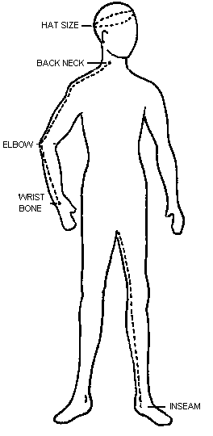

**COSTUME SHEET - FEMALE**

**Name ___________________________________________**

**Show ___________________________________________**

**Character _______________________________________**

**SIZES:** (OFTEN VARY FROM MEASUREMENTS.  GIVE BOTH.)

**Dress ___________        Blouse __________**

**Slacks __________            Shoes __________**

**MEASUREMENTS: (The waist is 3 inches above the bellybutton, upper hip is where you wear your pants and lower hip is right below your butt)**

**Height ___________  Weight ___________**

**Head ____________   Neck ____________**

**Bust ____________   Waist ____________**

**Upper Hip ________  Lower Hip________**

**Wrist ____________   Arm _____________**

**Butt ____________    Inseam ___________**

**Across shoulder _______________________**

**Shoulder to Waist ______________________**

**Back Neck to Wrist _____________________**

**Shoulder to Wrist ______________________**

**Back Neck to Floor _____________________**

**Waist to Knee (front) _______ (Back) _______**

**Waist to floor (front) ________ (Back) _______**

